Tasmania – 26th Largest Island in the World and Southernmost Settlement in Australia

In August of 1994, I was on a business trip that took me to Seoul, South Korea (by way of Portland, Oregon) Sydney, Australia, and on to Hobart, Tasmania for the annual Australian ESRI User Conference, known to the locals as “OZRI”. The 11 hour nonstop overnight flight from Seoul to Sydney on Korean Airlines was one of the best flights I’ve had the pleasure of experiencing. The inflight service by the lovely Korean flight attendants was very attentive, and the meals were outstanding. I was especially pleased with the very fresh, crisp green salad topped with a delicious, spicy Korean dressing and the braised beef short ribs with kimchi.
Early the next morning, we landed in Sydney and I took the airport shuttle bus to the Park Hyatt Hotel, beautifully situated downtown overlooking Sydney harbor. Since I had arrived early in the morning, my room wasn’t ready yet, so I had a cup of coffee in the hotel’s “Library Bar” and then took a walk along the Sydney harbor waterfront under gorgeous sunny skies. Upon returning to the hotel, I was shown to my room – a large suite decorated with gorgeous tropical mahogany furniture and luxurious white Italian marble throughout the immense bathroom, that was fitted with gold fixtures. From the balcony there was a stunning view of the world-famous Sydney Harbor Bridge and Opera House! (The Sydney Park Hyatt remains my favorite hotel)
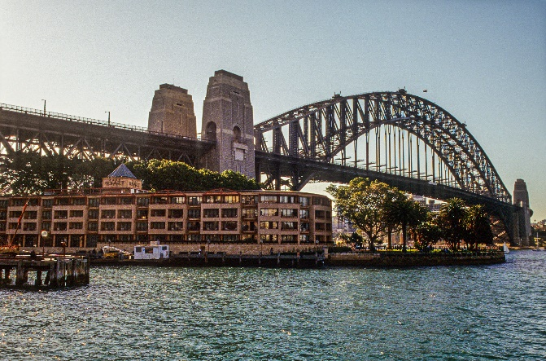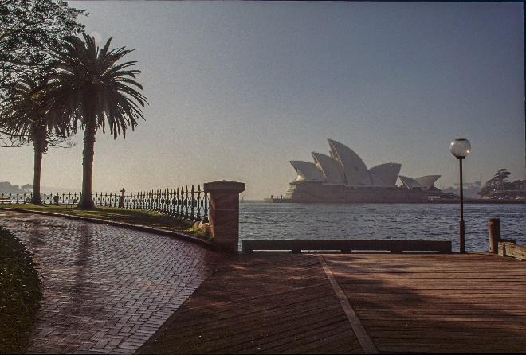
After a quick shower and change of clothes, I grabbed my camera and headed out to explore the Sydney harborside in the warm afternoon. During my walk, I discovered the weekly “Street Faire in the Rocks” – the location of which is the original place where the first prisoners/convicts from England landed. After wandering through the many shops and food stands in the street faire, I stopped at a small waterfront café called “Wolfie’s” for lunch as I looked out over the harbor and the Sydney Opera House. I ordered the “Prawns Outback”, which were several giant tiger prawns wrapped and steamed in bark – an amazing dish! The cold pint of Toohey’s Draft went very well with the meal.
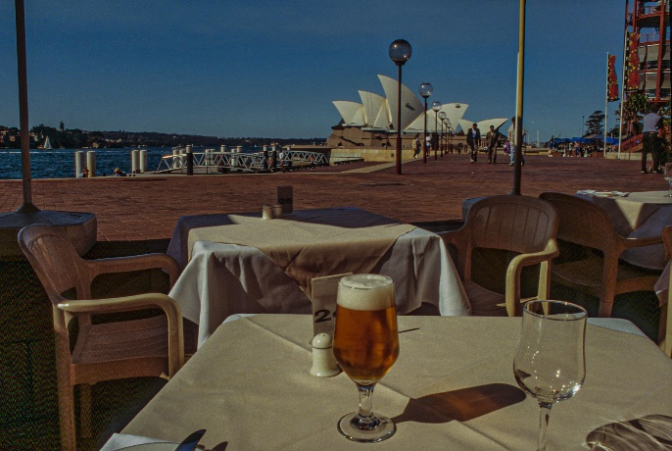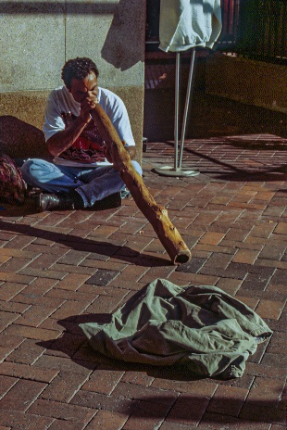
After lunch, I walked further along the waterfront and suddenly heard the beautiful, haunting sound from a young Aborigine man playing the traditional “Digeridoo” – I was entranced! Further down the waterfront was a “mechanical man” dancing to very loud metallic music – he was covered from head to toe in silver paint!
From the harborside, I walked over to the nearby Botanical Gardens where there were some beautiful views of the Sydney harbor, as well as the downtown skyline. Along the way I passed a huge tree filled with Parrots “squawking” at full volume!
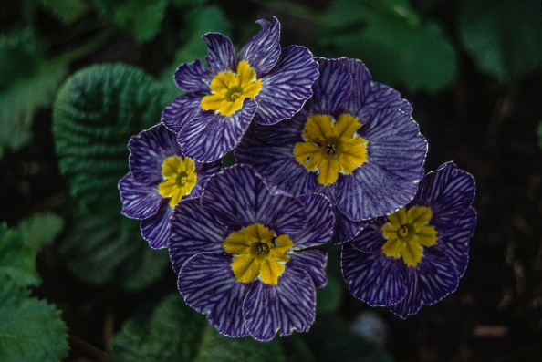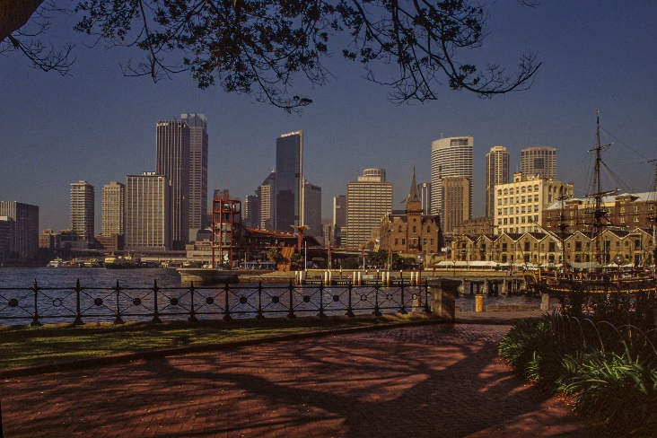
After my visit to the Botanical Gardens, I stopped for an ice-cold pint of Toohey’s Red Bitter at the “Oysterhouse” overlooking Sydney Cove. Later, when I returned to my room at the Park Hyatt Hotel, I sat on the balcony and watched the sun setting over the harbor, behind the Sydney Opera House – a stunning view! For dinner that evening, I walked along the waterfront to “Fish at the Rocks”, a small café serving a great selection of fresh seafood. Since the café didn’t have a bar, it was BYOB. So, I went next door to the pub in the Lord Nelson Hotel and bought a bottle of Australian Chardonnay. Returning to the café, I enjoyed an excellent dish of Thai fish cakes – very fresh and delicious! After dinner, I spotted the “Merchantile Pub” down the street. It looked like a pretty wild and crazy place, very local and crowded – but a lot of fun too! We all had a good time, but then promptly at 1:00am sharp, we were all tossed out!
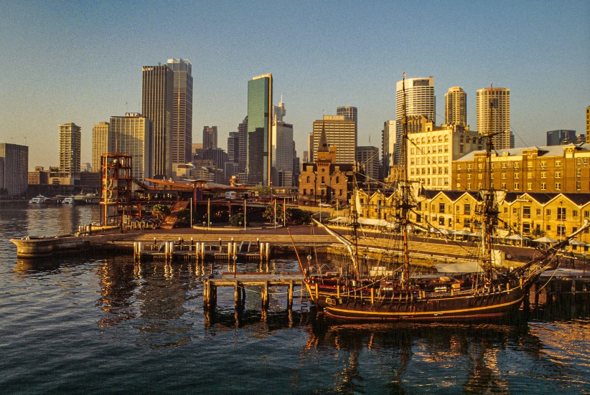
As I awoke early the next morning with the sunrise, I looked out the window to see the arrival of a large P&O cruise ship. After a quick breakfast, I prepared to leave Sydney for the flight to Hobart, Tasmania to attend the “OZRI” conference. But as I boarded the hotel shuttle to the airport, we encountered many delays due to the running of the Sydney Marathon race through downtown. However, it was a delightful flight on Ansett Australian Airlines to Hobart, at least until the landing in Hobart – a bit hairy, with 40mph winds and heavy rain. (not the best introduction to the city) Once I arrived at the Hotel Grand Chancellor downtown on the harbor, I found it to be a wonderful place overlooking the harbor and the mountains beyond, and my room had a great view facing the harbor.
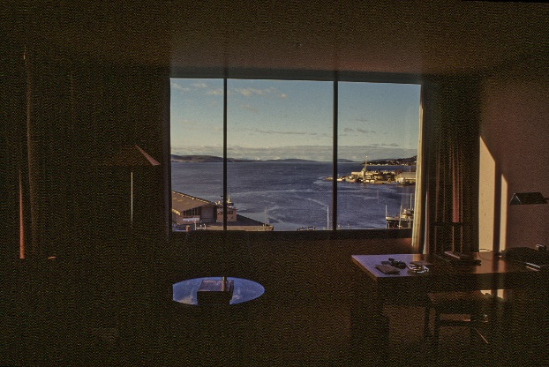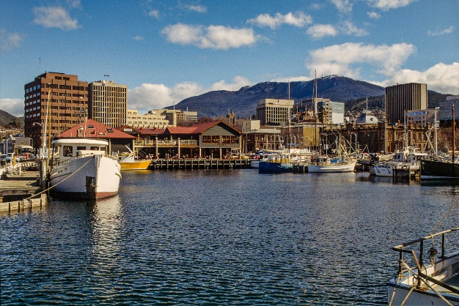

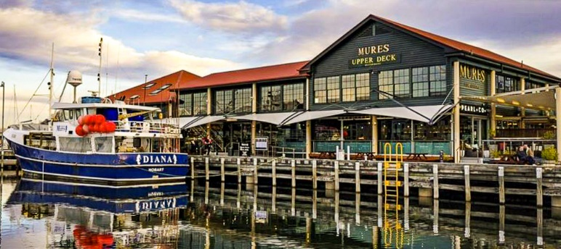
I joined the OZRI conference management staff for dinner that evening at “Mures Seafood Restaurant” on the waterfront. We were served a huge selection of three local fish that had been freshly caught that morning, as well as fresh Atlantic Salmon that is “farmed” in the waters of Hobart Bay. (thousands of miles from the ancestral home of Atlantic Salmon, however, the great distance had no adverse effect on the delicious taste of the fish!)
I awoke the next morning to a gorgeous view of the harbor from my hotel room. Later, I joined the OZRI conference staff to prepare several technical sessions and to meet with ESRI clients. That evening, I once again gathered with my ESRI-Australia colleagues for dinner at the “Drunken Admiral Seafarers Restaurant” near my hotel on the harbor. The restaurant was located in one of the old warehouses on the wharf, next to an old jam factory. The décor was like a “nautical” version of an American TGIF restaurant – very comfortable. The large bowl of fish chowder was excellent, along with a cold pint of local ale. For the main dish I ordered the “Sultan’s Emissary” – scallops and prawns tossed with a cashew nut satay sauce served with steamed rice and Asian market greens. It was simply fabulous! Later that night, we all returned to the conference center to prepare and rehearse for the opening session of the OZRI conference the following day.
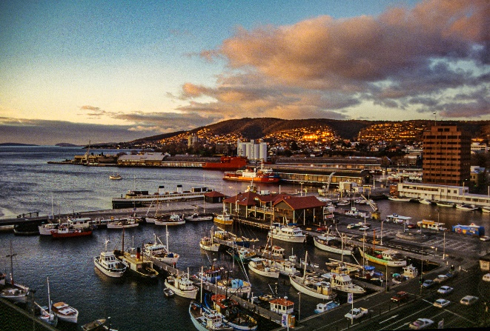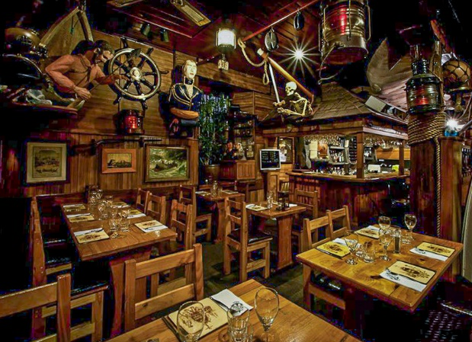
The next morning was the opening plenary session of the conference and the weather was changing rapidly, with heavy clouds moving toward Hobart from the southwest. At the lunch break I joined the OZRI conference staff and was introduced to a local brew from the Cascade Brewery that was founded in 1824 and is now the oldest continually operating brewery in Australia. It’s famous for its Premium Lager and a label that has the image of the infamous and extinct “Tasmanian Tiger”. The brewery also makes a “light” beer that’s named “Tigerhead Beer”, but I couldn’t help noticing its color was much darker than the full-strength lager. However, both were excellent!
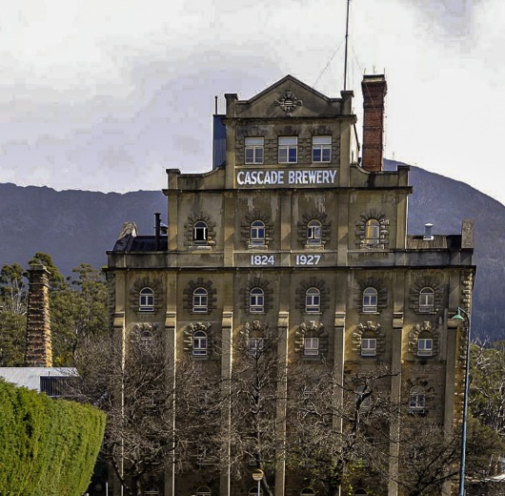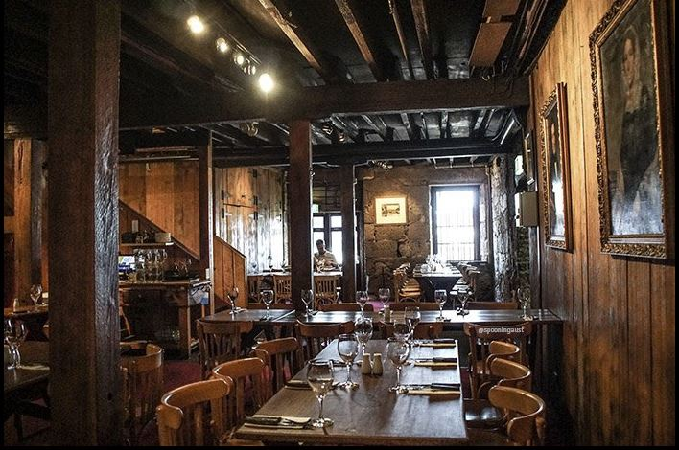
Later, we all went for dinner at the “Ball and Chain Bar & Grill” in Salamanca Place, a series old beautiful old sandstone warehouses on the wharf. The name of the restaurant originates from 1830 when it was built by chain gangs of convicts as part of the construction of Salamanca Place and the Hobart Wharf. It’s famous for its huge open fire grill and dry aged steaks. I was recommended to order venison steak and sausage, although Wallaby was also on the menu! Several excellent Australian wines were ordered, and it was clear from the conversation among the ESRI-Australia staff that there was a lot of competition between wines from South Australia (Melbourne), Western Australia (Perth), and New South Wales (Sydney). There was no discussion of wines from Europe, South Africa, Chile, or America! After a delightful dinner with the ESRI-Australia staff, I walked across the street to my hotel. As I looked around the harbor, I noticed the USA Antarctic Expedition’s supply ship – the “Aurora Australis”, which was docked in the port to re-supply for the next expedition. (It departed early the next morning bound for Antarctica)
The next day was the opening plenary session of “OZRI” and it went very well. After lunch, I took a couple of hours to walk around the harbor and the historic neighborhoods of Salamanca Place, Arthur Circus, and Battery Point Village. I had many great opportunities for photos under brilliant sunny skies and calm winds – rather unusual for Hobart. There were some beautiful views of Mt Wellington towering over the city. Then, after the conference that evening, I joined the ESRI-Australia staff again for dinner at a nearby Italian restaurant. And although we all had a great time together, the food was mediocre at best – certainly nothing special, unfortunately.
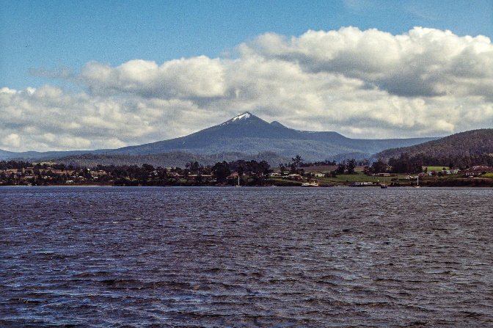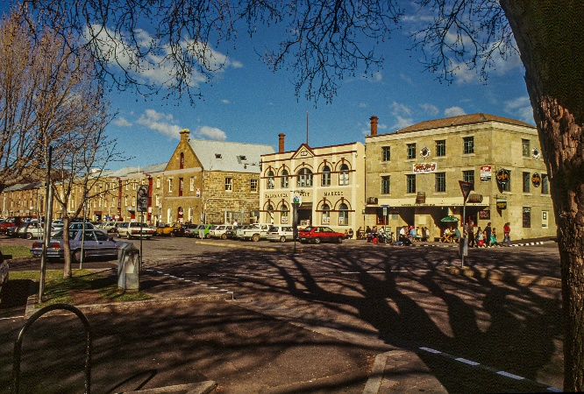
The following day the conference concluded with several excellent technical sessions and workshops, after which we all headed for the closing party. The dinner banquet was filled with traditional Australian dishes, including some wild game such as Wallaby and Ostrich. But the highlight of the evening was a performance by a very famous Australian comedian who delivered some hilarious comments on TV commercials in a very subtle, almost “deadpan” humor! Everyone really enjoyed the performance, and then we all made our way next door to the casino and “Regine’s Nightclub”. I called it an early evening at 11pm, but some people apparently stayed until the place closed at 5am! I had a lovely, quiet walk along the coast back to my hotel.
After breakfast in the hotel the next morning, I joined a coach tour to the summit of Mt Wellington overlooking the city and harbor. The views of Hobart and southwest Tasmania were spectacular, but it was very windy and quite chilly on the summit.
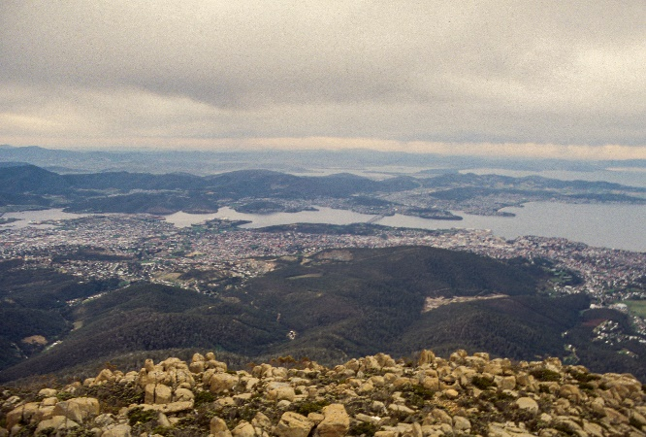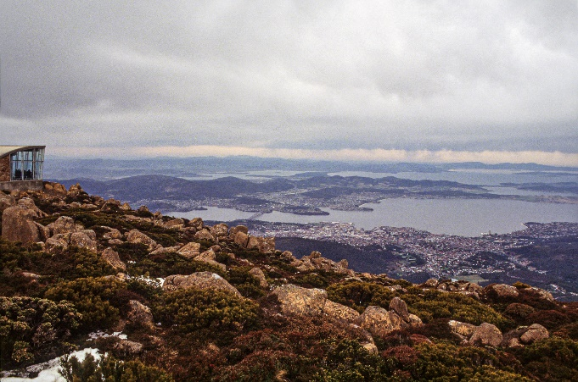
Upon returning to the city, I hiked along the path of the old abandoned Tasmanian Railway to the Botanical Gardens. In the process, I had to cross a major 4-lane highway during the height of the Friday rush hour traffic! However, once I reached the gardens, I spotted some gorgeous huge flowers that resembled pink pine cones! The Botanical Gardens had many very unusual plants and flowers in its collection. After making a safe crossing of a busy freeway, I had a great view of the old bridge over the Derwent River, a very high span across the deep river. Later, I was told that a large boat had collided with one of the bridge supports several years ago that resulted in 12 people plunging to their death! (the bridge support is still missing, but the deck of the bridge was rebuilt)
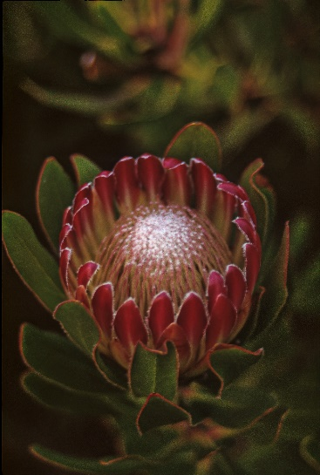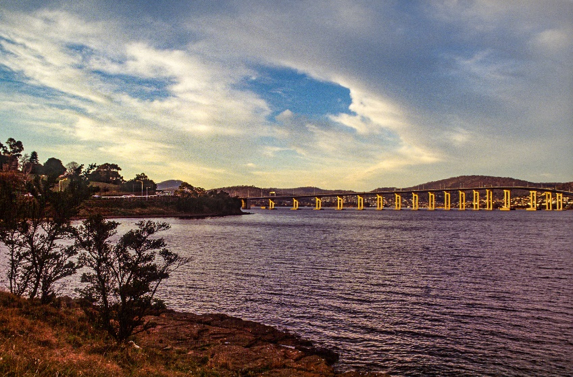
When I returned to the hotel, I met up with some of the OZRI conference staff by chance in the “Spinnaker Bar”. After a couple of drinks, we all went to dinner at the “Riviera Ristorante”. Although I enjoyed the company of my OZRI colleagues, I had to say it was not a good place – lousy service and bad food! But after dinner, we all headed back to the Spinnaker Bar and arrived just in time for Happy Hour at 9pm. As we sat at the bar, I watched people play a popular game that involved the flip of a coin. The rules were simple – if you called the toss correctly, your drink was free. Otherwise your drink was full price. Essentially it was a 2 for the price of one deal, if you were lucky! As the evening went on, we all went downstairs to a disco called “Maloney’s” where there was live music by “The Hot Chisels”! The place was very crowded and very local, with young women dancing on the bar. My first impression was that of a “pickup place”, a social “market” in many ways. Some of our group apparently stayed until 4am, but I left a lot earlier.
The next morning, I visited the Salamanca Farmers Market, where there was everything from fresh produce to lots of handmade local crafts, all displayed under beautiful clear blue skies and with stunning views of Mt Wellington in the distance. I had a wonderful time strolling through the market.
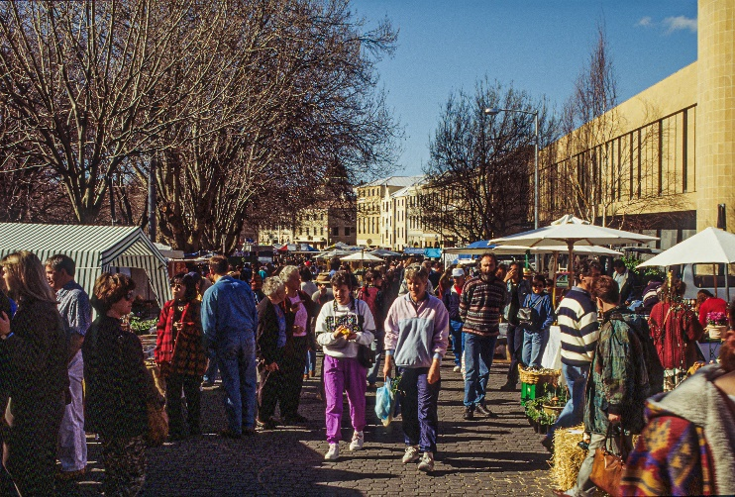
Later in the afternoon, Dr Peter Stuart from the University of Tasmania took us on tour of the “Huon Valley” southwest of Hobart to the southernmost settlement in Australia. Along the way we passed a lot of apple orchards and vineyards before we stopped at the “Dover Pub” for lunch. My order of scallops poached in white wine was superb – some of the best ever.
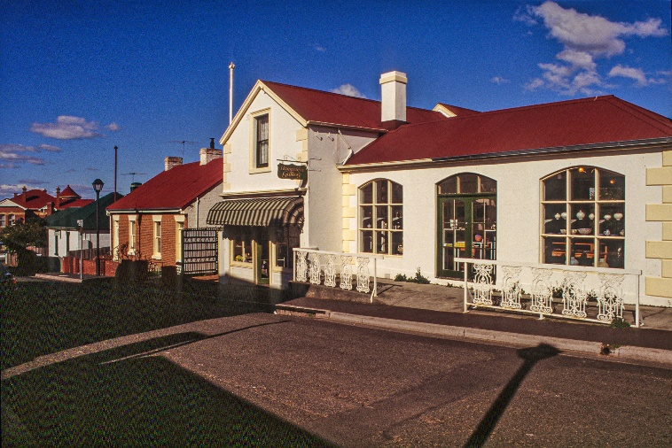
And the views from the terrace overlooking Esperance Bay were amazing. After lunch, Peter drove us to “Casey’s Steam and Doll Museum” nearby, but unfortunately, we were told they didn’t have any steam up that day, so none of the old locomotives were running. From the museum, we drove up to “Waratah Point Lookout” in Hartz Mountains National Park. As we walked along the narrow track (aka trail), we suddenly came to a wooden deck jutting out over a sheer cliff and next to a lovely waterfall. From the deck we had a stunning view of the Huon Valley and the entire southwest corner of Tasmania! Further up the track we reached a point just below sharp, rugged peaks above the tree line, where the landscape was very much like arctic tundra. Although we often think of Eucalyptus trees as being a “sub-tropical” species, this area was definitely “sub-alpine”! Further down the mountain were giant tree ferns – beautiful, yet most unusual.
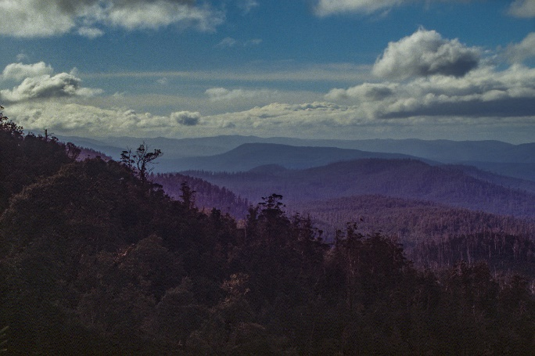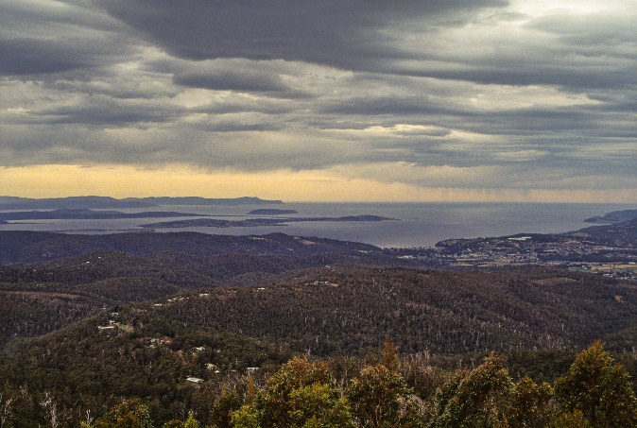
Upon returning to Hobart that evening, we had a wonderful dinner at the “Ball and Chain Bar & Grill” in Salamanca Place on the waterfront. My choice of Scotch Filet steak was perfectly grilled over the huge open fire in the center of the building. After dinner, I joined my OZRI colleagues for a pint at the “Corner Pub”, where we all sat around a large fireplace – very relaxing! I made it an early night in preparation for my flight to Jakarta, Indonesia where I would attend the ESRI-Indonesia GIS Conference.
The following morning, I boarded the flight to Jakarta, by way of Melbourne and Denpasar (Bali). On the route to Melbourne there were lovely views of western Tasmania before we arrived in Melbourne amid a heavy rainstorm. But on the way to Denpasar, the flight took us over Ayers Rock for a stunning view of the giant red monolith. It was a wonderful way to say farewell to Australia! (Jakarta is another story to be told later)

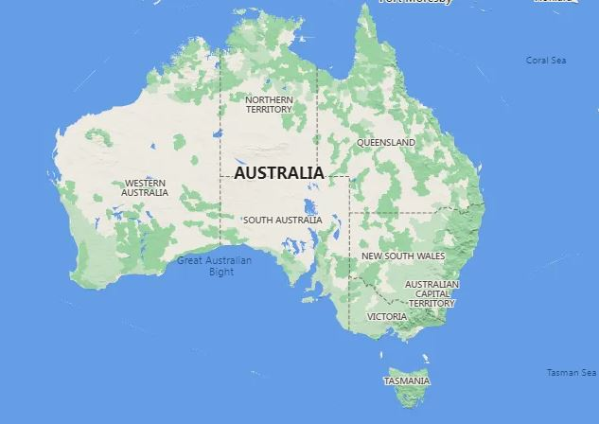
PHOTO GALLERY

Sydney, Australia

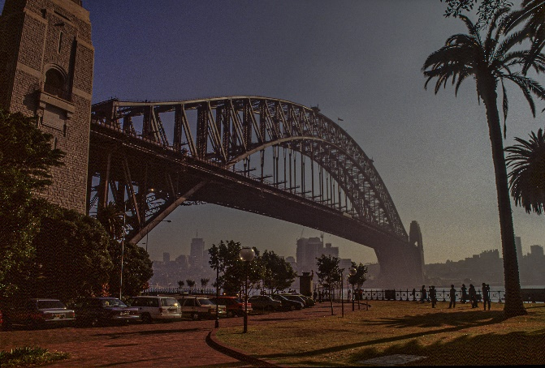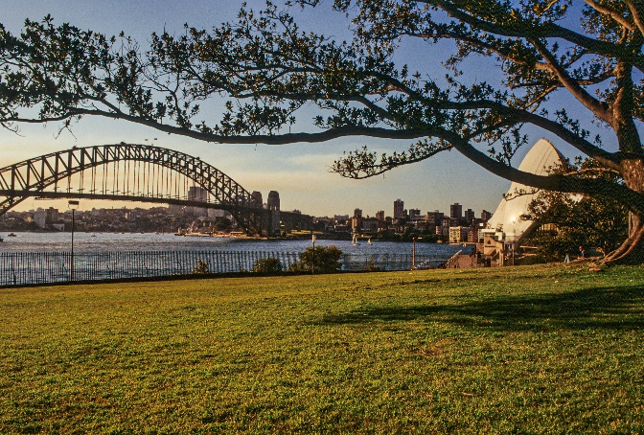

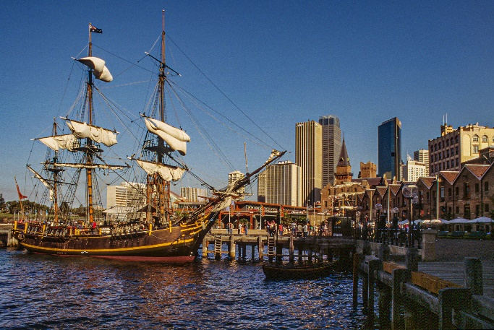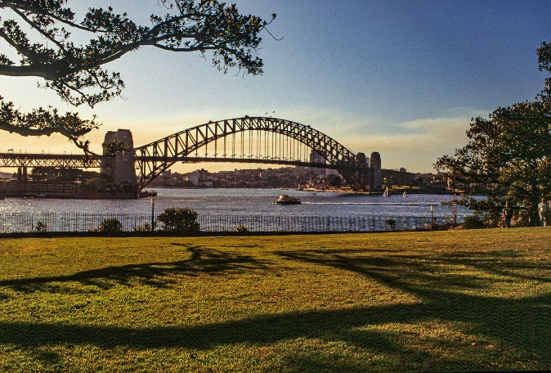

Hobart, Tasmania

